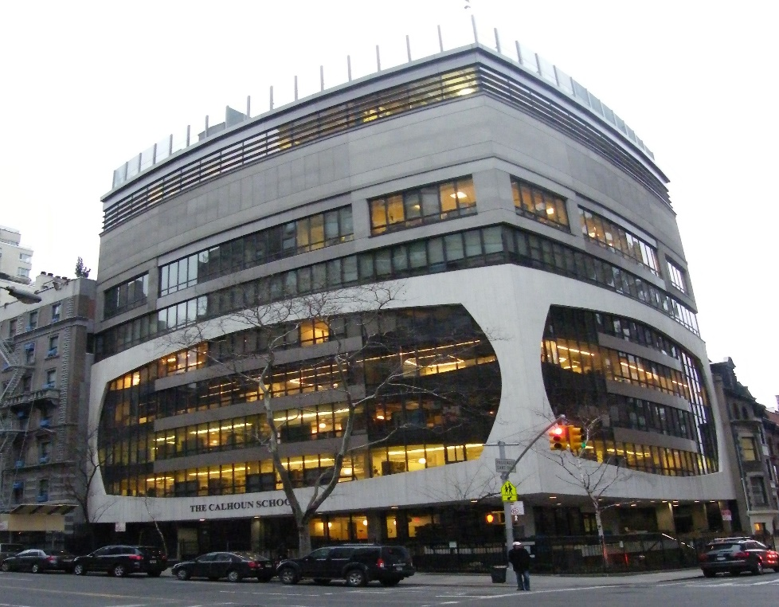

MINIMUM CAPACITY :-
The Minumum intake capacity
of students is between 300-620
children

LIBRARY :-
The Libarary is Available.

CANTEEN:-
The Canteen Facility is Available.

BOARDING :-
No availablility of boarding.

SPORTS :-
There are different categories
sports available.
Girls Volleyball
Boys Volleyball
Football

THE CALHOUN SCHOOL
YONKERS - SCHOOL

School Detail :-
As Manhattan’s open-concept school, our classrooms—and our way of learning—seek to break down barriers between and within disciplines, concepts and people in order to nurture flexibility, provoke inquiry and forge instructive connections.
As Manhattan’s open-concept school, our classrooms—and our way of learning—seek to break down barriers between and within disciplines, concepts and people in order to nurture flexibility, provoke inquiry and forge instructive connections.

